**Lab Project**

**A Video Game Retailer Transaction Database**

Tianchen Ren

G43187842

CSCI6441, Spring 2013

Submitted To

Rolando Fernandez

Computer Science

School of Engineering and Applied Science

George Washington University

Date: 03/23/2013

**Statement of Work (SOW)**

Tianchen Ren, G43187842

**Overview:**

This database is designed for video game retailer system to keep track of the stocks, rentals or orders of video games and membership program for gamers.

**Purpose and Objective:**

The database will enable the game retailer to list video games information of different platforms for keeping tracking with their release dates, stocks and prices. This will also house rental information such as renter’s name, credit card information, rental date and return date. This database will have information about customers, memberships, employees, video game information, benefits sold and rental information etc.

Database will have checks to keep information about the games and if any games’ stocks are of high value (say > 100) meanwhile they are out-dated (more than half a year). It will be creating for sale needs.

**Diagram Tool:**

Oracle SQL Developer Data Modeler Ver. 3.1.4.710

Platform Apple/MacOs 10.8.2

**Database:**

Oracle 11g.

**Hardware and Software:**

GWU server system

Operation system is MacOs.

Connect to Oracle via Oracle SQL Developer

**DDL and DML:**

SQL will be used for the DDL and DML.

Use Data Modeler to generate the DDL scripts from the physical data model.

Use SQL Developer to generate the DDL scripts.

**Entity Relationship Diagram**

**Major Entities and their descriptions**

1. Customer: customer_id, last_name, first_name, address, phone, is_membership, level, preferred_platform, preferred_gametype.
2. Membership_enrollment: transaction_number, renew_date, expire_date, price, customer_id, employee_id.
3. Employee: employee_id, last_name, first_name, address, phone, manager_id.
4. Game_information: game_id, game_title, type, company, release date, description, price, stocks.
5. Rental_information: invoice_id, rental_date, return_date, price, memo, customer_id, employee_id.
6. Rental_game: invoice_id, game_id, amount.
7. Order_information: order_id, datetime, total price, memo, custom_id, employee_id.
8. Order_game: order_id, game_id, amount.

**Logical ERD**

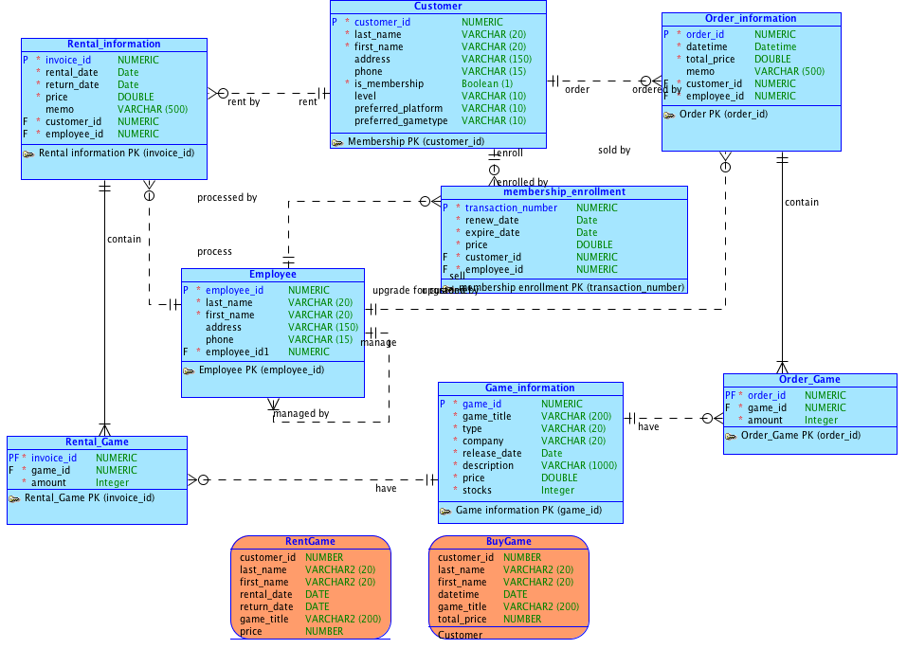

PDF copy attached for better review



**Physical ERD**

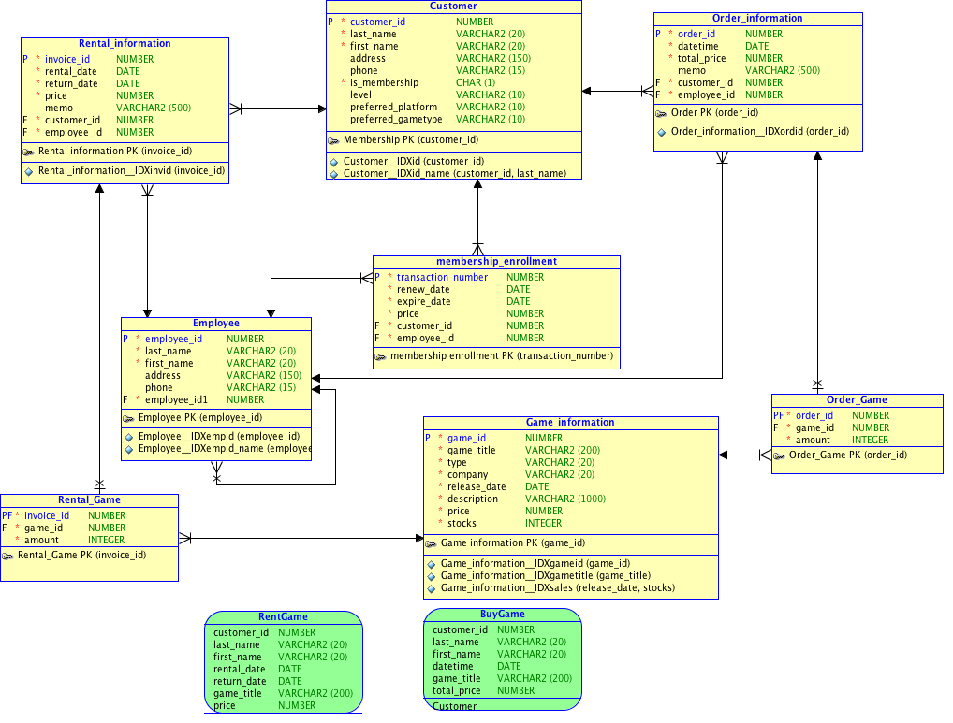

PDF copy attached for better review



**DDL (Data Definition Language)**

-- Generated by Oracle SQL Developer Data Modeler 3.1.4.710

-- at: 2013-04-04 20:14:18 EDT

-- site: Oracle Database 11g

-- type: Oracle Database 11g

CREATE TABLE Customer

(

customer_id NUMBER NOT NULL ,

last_name VARCHAR2 (20) NOT NULL ,

first_name VARCHAR2 (20) NOT NULL ,

address VARCHAR2 (150) ,

phone VARCHAR2 (15) ,

is_membership CHAR (1) NOT NULL ,

"level" VARCHAR2 (10) ,

preferred_platform VARCHAR2 (10) ,

preferred_gametype VARCHAR2 (10)

)

;

CREATE INDEX Customer__IDXid ON Customer

(

customer_id ASC

)

;

CREATE INDEX Customer__IDXid_name ON Customer

(

customer_id ASC ,

last_name ASC

)

;

ALTER TABLE Customer

ADD CONSTRAINT "Membership PK" PRIMARY KEY ( customer_id ) ;

CREATE TABLE Employee

(

employee_id NUMBER NOT NULL ,

last_name VARCHAR2 (20) NOT NULL ,

first_name VARCHAR2 (20) NOT NULL ,

address VARCHAR2 (150) ,

phone VARCHAR2 (15) ,

employee_id1 NUMBER NOT NULL

)

;

CREATE INDEX Employee__IDXempid ON Employee

(

employee_id ASC

)

;

CREATE INDEX Employee__IDXempid_name ON Employee

(

employee_id ASC ,

last_name ASC ,

first_name ASC

)

;

ALTER TABLE Employee

ADD CONSTRAINT "Employee PK" PRIMARY KEY ( employee_id ) ;

CREATE TABLE Game_information

(

game_id NUMBER NOT NULL ,

game_title VARCHAR2 (200) NOT NULL ,

type VARCHAR2 (20) NOT NULL ,

company VARCHAR2 (20) NOT NULL ,

release_date DATE NOT NULL ,

description VARCHAR2 (1000) NOT NULL ,

price NUMBER NOT NULL ,

stocks INTEGER NOT NULL

)

;

CREATE INDEX Game_information__IDXgameid ON Game_information

(

game_id ASC

)

;

CREATE INDEX Game_information__IDXgametitle ON Game_information

(

game_title ASC

)

;

CREATE INDEX Game_information__IDXsales ON Game_information

(

release_date ASC ,

stocks ASC

)

;

ALTER TABLE Game_information

ADD CONSTRAINT "Game information PK" PRIMARY KEY ( game_id ) ;

CREATE TABLE Order_Game

(

order_id NUMBER NOT NULL ,

game_id NUMBER NOT NULL ,

amount INTEGER NOT NULL

)

;

ALTER TABLE Order_Game

ADD CONSTRAINT "Order_Game PK" PRIMARY KEY ( order_id ) ;

CREATE TABLE Order_information

(

order_id NUMBER NOT NULL ,

datetime DATE NOT NULL ,

total_price NUMBER NOT NULL ,

memo VARCHAR2 (500) ,

customer_id NUMBER NOT NULL ,

employee_id NUMBER NOT NULL

)

;

CREATE INDEX Order_information__IDXordid ON Order_information

(

order_id ASC

)

;

ALTER TABLE Order_information

ADD CONSTRAINT "Order PK" PRIMARY KEY ( order_id ) ;

CREATE TABLE Rental_Game

(

invoice_id NUMBER NOT NULL ,

game_id NUMBER NOT NULL ,

amount INTEGER NOT NULL

)

;

ALTER TABLE Rental_Game

ADD CONSTRAINT "Rental_Game PK" PRIMARY KEY ( invoice_id ) ;

CREATE TABLE Rental_information

(

invoice_id NUMBER NOT NULL ,

rental_date DATE NOT NULL ,

return_date DATE NOT NULL ,

price NUMBER NOT NULL ,

memo VARCHAR2 (500) ,

customer_id NUMBER NOT NULL ,

employee_id NUMBER NOT NULL

)

;

ALTER TABLE Rental_information

ADD CONSTRAINT Rental_information_CKTIME

CHECK (datediff(dd, rental_date, return_date) < 90)

;

CREATE INDEX Rental_information__IDXinvid ON Rental_information

(

invoice_id ASC

)

;

ALTER TABLE Rental_information

ADD CONSTRAINT "Rental information PK" PRIMARY KEY ( invoice_id ) ;

CREATE TABLE membership_enrollment

(

transaction_number NUMBER NOT NULL ,

renew_date DATE NOT NULL ,

expire_date DATE NOT NULL ,

price NUMBER NOT NULL ,

customer_id NUMBER NOT NULL ,

employee_id NUMBER NOT NULL

)

;

ALTER TABLE membership_enrollment

ADD CONSTRAINT membership_enrollment_CKmemexp

CHECK (datediff(dd, renew_date, expire_date) > 0)

;

ALTER TABLE membership_enrollment

ADD CONSTRAINT "membership enrollment PK" PRIMARY KEY ( transaction_number ) ;

ALTER TABLE Rental_Game

ADD CONSTRAINT Relation_11 FOREIGN KEY

(

game_id

)

REFERENCES Game_information

(

game_id

)

;

ALTER TABLE Rental_Game

ADD CONSTRAINT Relation_12 FOREIGN KEY

(

invoice_id

)

REFERENCES Rental_information

(

invoice_id

)

ON DELETE CASCADE

;

ALTER TABLE Order_information

ADD CONSTRAINT Relation_2 FOREIGN KEY

(

customer_id

)

REFERENCES Customer

(

customer_id

)

;

ALTER TABLE Order_Game

ADD CONSTRAINT contains FOREIGN KEY

(

order_id

)

REFERENCES Order_information

(

order_id

)

ON DELETE CASCADE

;

ALTER TABLE Rental_information

ADD CONSTRAINT "do rent" FOREIGN KEY

(

employee_id

)

REFERENCES Employee

(

employee_id

)

;

ALTER TABLE Order_Game

ADD CONSTRAINT have FOREIGN KEY

(

game_id

)

REFERENCES Game_information

(

game_id

)

;

ALTER TABLE Employee

ADD CONSTRAINT manage FOREIGN KEY

(

employee_id1

)

REFERENCES Employee

(

employee_id

)

ON DELETE CASCADE

;

ALTER TABLE membership_enrollment

ADD CONSTRAINT "membership enroll" FOREIGN KEY

(

customer_id

)

REFERENCES Customer

(

customer_id

)

;

ALTER TABLE Rental_information

ADD CONSTRAINT rent FOREIGN KEY

(

customer_id

)

REFERENCES Customer

(

customer_id

)

;

ALTER TABLE Order_information

ADD CONSTRAINT "sell info" FOREIGN KEY

(

employee_id

)

REFERENCES Employee

(

employee_id

)

;

ALTER TABLE membership_enrollment

ADD CONSTRAINT "upgrade membership" FOREIGN KEY

(

employee_id

)

REFERENCES Employee

(

employee_id

)

;

CREATE OR REPLACE VIEW BuyGame AS

SELECT Customer.customer_id,

Customer.last_name,

Customer.first_name,

Order_information.datetime,

Game_information.game_title,

Order_information.total_price

FROM Customer

INNER JOIN Order_information

ON Customer.customer_id = Order_information.customer_id

INNER JOIN Order_Game

ON Order_information.order_id = Order_Game.order_id

INNER JOIN Game_information

ON Game_information.game_id = Order_Game.game_id ;

CREATE OR REPLACE VIEW RentGame AS

SELECT Customer.customer_id,

Customer.last_name,

Customer.first_name,

Rental_information.rental_date,

Rental_information.return_date,

Game_information.game_title,

Rental_information.price

FROM Customer

INNER JOIN Rental_information

ON Customer.customer_id = Rental_information.customer_id

INNER JOIN Rental_Game

ON Rental_information.invoice_id = Rental_Game.invoice_id

INNER JOIN Game_information

ON Game_information.game_id = Rental_Game.game_id ;

-- Oracle SQL Developer Data Modeler Summary Report:

--

-- CREATE TABLE 8

-- CREATE INDEX 9

-- ALTER TABLE 21

-- CREATE VIEW 2

-- CREATE PACKAGE 0

-- CREATE PACKAGE BODY 0

-- CREATE PROCEDURE 0

-- CREATE FUNCTION 0

-- CREATE TRIGGER 0

-- ALTER TRIGGER 0

-- CREATE STRUCTURED TYPE 0

-- CREATE COLLECTION TYPE 0

-- CREATE CLUSTER 0

-- CREATE CONTEXT 0

-- CREATE DATABASE 0

-- CREATE DIMENSION 0

-- CREATE DIRECTORY 0

-- CREATE DISK GROUP 0

-- CREATE ROLE 0

-- CREATE ROLLBACK SEGMENT 0

-- CREATE SEQUENCE 0

-- CREATE MATERIALIZED VIEW 0

-- CREATE SYNONYM 0

-- CREATE TABLESPACE 0

-- CREATE USER 0

--

-- DROP TABLESPACE 0

-- DROP DATABASE 0

--

-- ERRORS 0

-- WARNINGS 0

Attaching DDL scripts



**DML (Data Manipulation Language)**

--------------------------------------------------------

-- File created - Friday-April-05-2013

--------------------------------------------------------

REM INSERTING into CS6441TCR.CUSTOMER

SET DEFINE OFF;

Insert into CS6441TCR.CUSTOMER (CUSTOMER_ID,LAST_NAME,FIRST_NAME,ADDRESS,PHONE,IS_MEMBERSHIP,"level",PREFERRED_PLATFORM,PREFERRED_GAMETYPE) values (1,'A','Bell','1495 E St','8126572834','1','gold','xbox360','rpg');

Insert into CS6441TCR.CUSTOMER (CUSTOMER_ID,LAST_NAME,FIRST_NAME,ADDRESS,PHONE,IS_MEMBERSHIP,"level",PREFERRED_PLATFORM,PREFERRED_GAMETYPE) values (2,'B','Carol','23 Rt Blvd','2228312345','0',null,null,null);

Insert into CS6441TCR.CUSTOMER (CUSTOMER_ID,LAST_NAME,FIRST_NAME,ADDRESS,PHONE,IS_MEMBERSHIP,"level",PREFERRED_PLATFORM,PREFERRED_GAMETYPE) values (3,'C','Doll','922 23th st','1875497619','1','bronze','wii','svg');

Insert into CS6441TCR.CUSTOMER (CUSTOMER_ID,LAST_NAME,FIRST_NAME,ADDRESS,PHONE,IS_MEMBERSHIP,"level",PREFERRED_PLATFORM,PREFERRED_GAMETYPE) values (4,'D','Elliott','3807 Rose Dvw','2875310984','1','silver','ps3','act');

Insert into CS6441TCR.CUSTOMER (CUSTOMER_ID,LAST_NAME,FIRST_NAME,ADDRESS,PHONE,IS_MEMBERSHIP,"level",PREFERRED_PLATFORM,PREFERRED_GAMETYPE) values (5,'E','Frank','36 7th st','1238691234','0',null,null,null);

Insert into CS6441TCR.CUSTOMER (CUSTOMER_ID,LAST_NAME,FIRST_NAME,ADDRESS,PHONE,IS_MEMBERSHIP,"level",PREFERRED_PLATFORM,PREFERRED_GAMETYPE) values (6,'F','Glen','897 s gath st','8365012347','0',null,null,null);

Insert into CS6441TCR.CUSTOMER (CUSTOMER_ID,LAST_NAME,FIRST_NAME,ADDRESS,PHONE,IS_MEMBERSHIP,"level",PREFERRED_PLATFORM,PREFERRED_GAMETYPE) values (7,'G','Hawlett','83 apple dvw','7482359012','0',null,null,null);

Insert into CS6441TCR.CUSTOMER (CUSTOMER_ID,LAST_NAME,FIRST_NAME,ADDRESS,PHONE,IS_MEMBERSHIP,"level",PREFERRED_PLATFORM,PREFERRED_GAMETYPE) values (8,'H','Ivey','90 E st','3764243973','1','diamond','ps3','act');

Insert into CS6441TCR.CUSTOMER (CUSTOMER_ID,LAST_NAME,FIRST_NAME,ADDRESS,PHONE,IS_MEMBERSHIP,"level",PREFERRED_PLATFORM,PREFERRED_GAMETYPE) values (9,'I','Jill','5908 napkin blvd','1827452391','0',null,null,null);

Insert into CS6441TCR.CUSTOMER (CUSTOMER_ID,LAST_NAME,FIRST_NAME,ADDRESS,PHONE,IS_MEMBERSHIP,"level",PREFERRED_PLATFORM,PREFERRED_GAMETYPE) values (10,'J','Kiri','223 5th st','6658432145','0',null,null,null);

Insert into CS6441TCR.CUSTOMER (CUSTOMER_ID,LAST_NAME,FIRST_NAME,ADDRESS,PHONE,IS_MEMBERSHIP,"level",PREFERRED_PLATFORM,PREFERRED_GAMETYPE) values (11,'K','Lily','7 11th ave','8432579023','1','bronze','xbox360','rpg');

Insert into CS6441TCR.CUSTOMER (CUSTOMER_ID,LAST_NAME,FIRST_NAME,ADDRESS,PHONE,IS_MEMBERSHIP,"level",PREFERRED_PLATFORM,PREFERRED_GAMETYPE) values (12,'L','Merle','89 s tason rd','2435789542','1','gold','ps3','svg');

Insert into CS6441TCR.CUSTOMER (CUSTOMER_ID,LAST_NAME,FIRST_NAME,ADDRESS,PHONE,IS_MEMBERSHIP,"level",PREFERRED_PLATFORM,PREFERRED_GAMETYPE) values (13,'M','Noosa','5923-100 s drion road','1023456789','1','gold','nds','act');

Insert into CS6441TCR.CUSTOMER (CUSTOMER_ID,LAST_NAME,FIRST_NAME,ADDRESS,PHONE,IS_MEMBERSHIP,"level",PREFERRED_PLATFORM,PREFERRED_GAMETYPE) values (14,'N','Opera','24 s tanley road','0957641245','0',null,null,null);

Insert into CS6441TCR.CUSTOMER (CUSTOMER_ID,LAST_NAME,FIRST_NAME,ADDRESS,PHONE,IS_MEMBERSHIP,"level",PREFERRED_PLATFORM,PREFERRED_GAMETYPE) values (15,'O','Peter','3013 9th st','8023485712','0',null,null,null);

REM INSERTING into CS6441TCR.EMPLOYEE

SET DEFINE OFF;

Insert into CS6441TCR.EMPLOYEE (EMPLOYEE_ID,LAST_NAME,FIRST_NAME,ADDRESS,PHONE,EMPLOYEE_ID1) values (1,'P','Qatar','1495 E St','8126572834',1);

Insert into CS6441TCR.EMPLOYEE (EMPLOYEE_ID,LAST_NAME,FIRST_NAME,ADDRESS,PHONE,EMPLOYEE_ID1) values (2,'Q','Noll','23 Rt Blvd','2228312345',1);

Insert into CS6441TCR.EMPLOYEE (EMPLOYEE_ID,LAST_NAME,FIRST_NAME,ADDRESS,PHONE,EMPLOYEE_ID1) values (3,'R','Fik','922 23th st','1875497619',1);

Insert into CS6441TCR.EMPLOYEE (EMPLOYEE_ID,LAST_NAME,FIRST_NAME,ADDRESS,PHONE,EMPLOYEE_ID1) values (4,'S','Hata','3807 Rose Dvw','2875310984',1);

Insert into CS6441TCR.EMPLOYEE (EMPLOYEE_ID,LAST_NAME,FIRST_NAME,ADDRESS,PHONE,EMPLOYEE_ID1) values (5,'T','Melon','36 7th st','1238691234',1);

Insert into CS6441TCR.EMPLOYEE (EMPLOYEE_ID,LAST_NAME,FIRST_NAME,ADDRESS,PHONE,EMPLOYEE_ID1) values (6,'U','Lucy','897 s gath st','8365012347',1);

Insert into CS6441TCR.EMPLOYEE (EMPLOYEE_ID,LAST_NAME,FIRST_NAME,ADDRESS,PHONE,EMPLOYEE_ID1) values (7,'V','Oper','83 apple dvw','7482359012',1);

Insert into CS6441TCR.EMPLOYEE (EMPLOYEE_ID,LAST_NAME,FIRST_NAME,ADDRESS,PHONE,EMPLOYEE_ID1) values (8,'W','Titan','90 E st','3764243973',1);

Insert into CS6441TCR.EMPLOYEE (EMPLOYEE_ID,LAST_NAME,FIRST_NAME,ADDRESS,PHONE,EMPLOYEE_ID1) values (9,'X','Washington','5908 napkin blvd','1827452391',1);

Insert into CS6441TCR.EMPLOYEE (EMPLOYEE_ID,LAST_NAME,FIRST_NAME,ADDRESS,PHONE,EMPLOYEE_ID1) values (10,'Y','Kiri','223 5th st','6658432145',1);

Insert into CS6441TCR.EMPLOYEE (EMPLOYEE_ID,LAST_NAME,FIRST_NAME,ADDRESS,PHONE,EMPLOYEE_ID1) values (11,'Z','Lily','7 11th ave','8432579023',1);

Insert into CS6441TCR.EMPLOYEE (EMPLOYEE_ID,LAST_NAME,FIRST_NAME,ADDRESS,PHONE,EMPLOYEE_ID1) values (12,'S','Bell','89 s tason rd','2435789542',1);

Insert into CS6441TCR.EMPLOYEE (EMPLOYEE_ID,LAST_NAME,FIRST_NAME,ADDRESS,PHONE,EMPLOYEE_ID1) values (13,'C','Cyan','5923-100 s drion road','1023456789',1);

Insert into CS6441TCR.EMPLOYEE (EMPLOYEE_ID,LAST_NAME,FIRST_NAME,ADDRESS,PHONE,EMPLOYEE_ID1) values (14,'T','Yap','24 s tanley road','0957641245',1);

Insert into CS6441TCR.EMPLOYEE (EMPLOYEE_ID,LAST_NAME,FIRST_NAME,ADDRESS,PHONE,EMPLOYEE_ID1) values (15,'Y','Zebra','3013 9th st','8023485712',1);

REM INSERTING into CS6441TCR.GAME_INFORMATION

SET DEFINE OFF;

Insert into CS6441TCR.GAME_INFORMATION (GAME_ID,GAME_TITLE,TYPE,COMPANY,RELEASE_DATE,DESCRIPTION,PRICE,STOCKS) values (1,'cod6','fps','ea',to_date('23-SEP-07','DD-MON-RR'),'cod6',59.99,109);

Insert into CS6441TCR.GAME_INFORMATION (GAME_ID,GAME_TITLE,TYPE,COMPANY,RELEASE_DATE,DESCRIPTION,PRICE,STOCKS) values (2,'last planet','act','sce',to_date('04-FEB-10','DD-MON-RR'),'lp',49.99,450);

Insert into CS6441TCR.GAME_INFORMATION (GAME_ID,GAME_TITLE,TYPE,COMPANY,RELEASE_DATE,DESCRIPTION,PRICE,STOCKS) values (3,'ff13-2','rpg','se',to_date('10-DEC-04','DD-MON-RR'),'ff',44.99,290);

Insert into CS6441TCR.GAME_INFORMATION (GAME_ID,GAME_TITLE,TYPE,COMPANY,RELEASE_DATE,DESCRIPTION,PRICE,STOCKS) values (4,'super mario','act','nintendo',to_date('03-JUL-13','DD-MON-RR'),'mario',24.99,1043);

Insert into CS6441TCR.GAME_INFORMATION (GAME_ID,GAME_TITLE,TYPE,COMPANY,RELEASE_DATE,DESCRIPTION,PRICE,STOCKS) values (5,'doom3','rpg','blizzard',to_date('12-JUN-12','DD-MON-RR'),'doom',34.99,230);

Insert into CS6441TCR.GAME_INFORMATION (GAME_ID,GAME_TITLE,TYPE,COMPANY,RELEASE_DATE,DESCRIPTION,PRICE,STOCKS) values (6,'dq14','rpg','se',to_date('08-MAY-08','DD-MON-RR'),'dq',19.99,2784);

Insert into CS6441TCR.GAME_INFORMATION (GAME_ID,GAME_TITLE,TYPE,COMPANY,RELEASE_DATE,DESCRIPTION,PRICE,STOCKS) values (7,'battle field 4','fps','ea',to_date('08-MAR-10','DD-MON-RR'),'bf4',69.99,1123);

Insert into CS6441TCR.GAME_INFORMATION (GAME_ID,GAME_TITLE,TYPE,COMPANY,RELEASE_DATE,DESCRIPTION,PRICE,STOCKS) values (8,'crysis 3','fps','capcom',to_date('01-JAN-14','DD-MON-RR'),'cc3',49.99,983);

Insert into CS6441TCR.GAME_INFORMATION (GAME_ID,GAME_TITLE,TYPE,COMPANY,RELEASE_DATE,DESCRIPTION,PRICE,STOCKS) values (9,'dirt 3','rac','koei',to_date('03-NOV-03','DD-MON-RR'),'d3',19.99,122);

Insert into CS6441TCR.GAME_INFORMATION (GAME_ID,GAME_TITLE,TYPE,COMPANY,RELEASE_DATE,DESCRIPTION,PRICE,STOCKS) values (10,'dmc 4','act','capcom',to_date('09-MAR-06','DD-MON-RR'),'dmc',24.99,1877);

Insert into CS6441TCR.GAME_INFORMATION (GAME_ID,GAME_TITLE,TYPE,COMPANY,RELEASE_DATE,DESCRIPTION,PRICE,STOCKS) values (11,'planet army','act','sce',to_date('04-OCT-07','DD-MON-RR'),'pa',14.99,532);

Insert into CS6441TCR.GAME_INFORMATION (GAME_ID,GAME_TITLE,TYPE,COMPANY,RELEASE_DATE,DESCRIPTION,PRICE,STOCKS) values (12,'simlife','sim','ea',to_date('02-APR-13','DD-MON-RR'),'sim3',29.99,2983);

Insert into CS6441TCR.GAME_INFORMATION (GAME_ID,GAME_TITLE,TYPE,COMPANY,RELEASE_DATE,DESCRIPTION,PRICE,STOCKS) values (13,'mo6','rpg','konami',to_date('07-SEP-12','DD-MON-RR'),'mo',19.99,98);

Insert into CS6441TCR.GAME_INFORMATION (GAME_ID,GAME_TITLE,TYPE,COMPANY,RELEASE_DATE,DESCRIPTION,PRICE,STOCKS) values (14,'nfs13','rac','sce',to_date('11-AUG-13','DD-MON-RR'),'nfs',24.99,348);

Insert into CS6441TCR.GAME_INFORMATION (GAME_ID,GAME_TITLE,TYPE,COMPANY,RELEASE_DATE,DESCRIPTION,PRICE,STOCKS) values (15,'fifa','spt','ea',to_date('03-SEP-09','DD-MON-RR'),'fifa',34.99,821);

Insert into CS6441TCR.GAME_INFORMATION (GAME_ID,GAME_TITLE,TYPE,COMPANY,RELEASE_DATE,DESCRIPTION,PRICE,STOCKS) values (16,'dance central 3','mug','konami',to_date('08-APR-13','DD-MON-RR'),'dc3',24.99,5234);

REM INSERTING into CS6441TCR.MEMBERSHIP_ENROLLMENT

SET DEFINE OFF;

Insert into CS6441TCR.MEMBERSHIP_ENROLLMENT (TRANSACTION_NUMBER,RENEW_DATE,EXPIRE_DATE,PRICE,CUSTOMER_ID,EMPLOYEE_ID) values (1,to_date('03-JUN-12','DD-MON-RR'),to_date('04-MAY-13','DD-MON-RR'),120,4,9);

Insert into CS6441TCR.MEMBERSHIP_ENROLLMENT (TRANSACTION_NUMBER,RENEW_DATE,EXPIRE_DATE,PRICE,CUSTOMER_ID,EMPLOYEE_ID) values (2,to_date('04-SEP-12','DD-MON-RR'),to_date('04-JUN-13','DD-MON-RR'),90,3,2);

Insert into CS6441TCR.MEMBERSHIP_ENROLLMENT (TRANSACTION_NUMBER,RENEW_DATE,EXPIRE_DATE,PRICE,CUSTOMER_ID,EMPLOYEE_ID) values (3,to_date('23-OCT-10','DD-MON-RR'),to_date('22-OCT-14','DD-MON-RR'),450,8,4);

Insert into CS6441TCR.MEMBERSHIP_ENROLLMENT (TRANSACTION_NUMBER,RENEW_DATE,EXPIRE_DATE,PRICE,CUSTOMER_ID,EMPLOYEE_ID) values (4,to_date('01-JAN-13','DD-MON-RR'),to_date('01-JUN-13','DD-MON-RR'),60,12,7);

Insert into CS6441TCR.MEMBERSHIP_ENROLLMENT (TRANSACTION_NUMBER,RENEW_DATE,EXPIRE_DATE,PRICE,CUSTOMER_ID,EMPLOYEE_ID) values (5,to_date('03-MAY-10','DD-MON-RR'),to_date('02-DEC-13','DD-MON-RR'),240,13,4);

Insert into CS6441TCR.MEMBERSHIP_ENROLLMENT (TRANSACTION_NUMBER,RENEW_DATE,EXPIRE_DATE,PRICE,CUSTOMER_ID,EMPLOYEE_ID) values (6,to_date('04-FEB-11','DD-MON-RR'),to_date('03-JAN-14','DD-MON-RR'),290,1,3);

Insert into CS6441TCR.MEMBERSHIP_ENROLLMENT (TRANSACTION_NUMBER,RENEW_DATE,EXPIRE_DATE,PRICE,CUSTOMER_ID,EMPLOYEE_ID) values (7,to_date('07-NOV-12','DD-MON-RR'),to_date('06-FEB-13','DD-MON-RR'),40,11,13);

REM INSERTING into CS6441TCR.ORDER_GAME

SET DEFINE OFF;

Insert into CS6441TCR.ORDER_GAME (ORDER_ID,GAME_ID,AMOUNT) values (1,3,1);

Insert into CS6441TCR.ORDER_GAME (ORDER_ID,GAME_ID,AMOUNT) values (2,4,1);

Insert into CS6441TCR.ORDER_GAME (ORDER_ID,GAME_ID,AMOUNT) values (3,7,1);

Insert into CS6441TCR.ORDER_GAME (ORDER_ID,GAME_ID,AMOUNT) values (4,2,3);

Insert into CS6441TCR.ORDER_GAME (ORDER_ID,GAME_ID,AMOUNT) values (5,7,4);

Insert into CS6441TCR.ORDER_GAME (ORDER_ID,GAME_ID,AMOUNT) values (6,2,2);

Insert into CS6441TCR.ORDER_GAME (ORDER_ID,GAME_ID,AMOUNT) values (7,13,2);

Insert into CS6441TCR.ORDER_GAME (ORDER_ID,GAME_ID,AMOUNT) values (8,5,1);

Insert into CS6441TCR.ORDER_GAME (ORDER_ID,GAME_ID,AMOUNT) values (9,12,3);

Insert into CS6441TCR.ORDER_GAME (ORDER_ID,GAME_ID,AMOUNT) values (10,2,4);

Insert into CS6441TCR.ORDER_GAME (ORDER_ID,GAME_ID,AMOUNT) values (11,3,5);

REM INSERTING into CS6441TCR.ORDER_INFORMATION

SET DEFINE OFF;

Insert into CS6441TCR.ORDER_INFORMATION (ORDER_ID,DATETIME,TOTAL_PRICE,MEMO,CUSTOMER_ID,EMPLOYEE_ID) values (1,to_date('23-JUN-11','DD-MON-RR'),39.99,'N',13,5);

Insert into CS6441TCR.ORDER_INFORMATION (ORDER_ID,DATETIME,TOTAL_PRICE,MEMO,CUSTOMER_ID,EMPLOYEE_ID) values (2,to_date('05-DEC-11','DD-MON-RR'),29.99,'N',2,4);

Insert into CS6441TCR.ORDER_INFORMATION (ORDER_ID,DATETIME,TOTAL_PRICE,MEMO,CUSTOMER_ID,EMPLOYEE_ID) values (3,to_date('04-JAN-12','DD-MON-RR'),24.99,'N',5,2);

Insert into CS6441TCR.ORDER_INFORMATION (ORDER_ID,DATETIME,TOTAL_PRICE,MEMO,CUSTOMER_ID,EMPLOYEE_ID) values (4,to_date('09-MAR-12','DD-MON-RR'),59.99,'N',9,14);

Insert into CS6441TCR.ORDER_INFORMATION (ORDER_ID,DATETIME,TOTAL_PRICE,MEMO,CUSTOMER_ID,EMPLOYEE_ID) values (5,to_date('12-APR-12','DD-MON-RR'),49.99,'N',15,5);

Insert into CS6441TCR.ORDER_INFORMATION (ORDER_ID,DATETIME,TOTAL_PRICE,MEMO,CUSTOMER_ID,EMPLOYEE_ID) values (6,to_date('23-JUL-12','DD-MON-RR'),34.99,'N',9,7);

Insert into CS6441TCR.ORDER_INFORMATION (ORDER_ID,DATETIME,TOTAL_PRICE,MEMO,CUSTOMER_ID,EMPLOYEE_ID) values (7,to_date('04-SEP-12','DD-MON-RR'),94.99,'N',8,5);

Insert into CS6441TCR.ORDER_INFORMATION (ORDER_ID,DATETIME,TOTAL_PRICE,MEMO,CUSTOMER_ID,EMPLOYEE_ID) values (8,to_date('19-NOV-12','DD-MON-RR'),24.99,'N',13,8);

Insert into CS6441TCR.ORDER_INFORMATION (ORDER_ID,DATETIME,TOTAL_PRICE,MEMO,CUSTOMER_ID,EMPLOYEE_ID) values (9,to_date('18-FEB-13','DD-MON-RR'),39.99,'N',3,10);

Insert into CS6441TCR.ORDER_INFORMATION (ORDER_ID,DATETIME,TOTAL_PRICE,MEMO,CUSTOMER_ID,EMPLOYEE_ID) values (10,to_date('23-FEB-13','DD-MON-RR'),49.99,'N',7,2);

Insert into CS6441TCR.ORDER_INFORMATION (ORDER_ID,DATETIME,TOTAL_PRICE,MEMO,CUSTOMER_ID,EMPLOYEE_ID) values (11,to_date('04-APR-13','DD-MON-RR'),19.99,'N',11,1);

REM INSERTING into CS6441TCR.RENTAL_GAME

SET DEFINE OFF;

Insert into CS6441TCR.RENTAL_GAME (INVOICE_ID,GAME_ID,AMOUNT) values (1,10,1);

Insert into CS6441TCR.RENTAL_GAME (INVOICE_ID,GAME_ID,AMOUNT) values (2,2,1);

Insert into CS6441TCR.RENTAL_GAME (INVOICE_ID,GAME_ID,AMOUNT) values (3,3,2);

Insert into CS6441TCR.RENTAL_GAME (INVOICE_ID,GAME_ID,AMOUNT) values (4,4,1);

Insert into CS6441TCR.RENTAL_GAME (INVOICE_ID,GAME_ID,AMOUNT) values (5,7,1);

Insert into CS6441TCR.RENTAL_GAME (INVOICE_ID,GAME_ID,AMOUNT) values (6,5,1);

Insert into CS6441TCR.RENTAL_GAME (INVOICE_ID,GAME_ID,AMOUNT) values (7,14,1);

Insert into CS6441TCR.RENTAL_GAME (INVOICE_ID,GAME_ID,AMOUNT) values (8,13,1);

Insert into CS6441TCR.RENTAL_GAME (INVOICE_ID,GAME_ID,AMOUNT) values (9,9,1);

REM INSERTING into CS6441TCR.RENTAL_INFORMATION

SET DEFINE OFF;

Insert into CS6441TCR.RENTAL_INFORMATION (INVOICE_ID,RENTAL_DATE,RETURN_DATE,PRICE,MEMO,CUSTOMER_ID,EMPLOYEE_ID) values (1,to_date('03-JUN-10','DD-MON-RR'),to_date('23-AUG-10','DD-MON-RR'),19.45,'Y',1,2);

Insert into CS6441TCR.RENTAL_INFORMATION (INVOICE_ID,RENTAL_DATE,RETURN_DATE,PRICE,MEMO,CUSTOMER_ID,EMPLOYEE_ID) values (2,to_date('14-OCT-10','DD-MON-RR'),to_date('23-DEC-10','DD-MON-RR'),23.48,'Y',14,10);

Insert into CS6441TCR.RENTAL_INFORMATION (INVOICE_ID,RENTAL_DATE,RETURN_DATE,PRICE,MEMO,CUSTOMER_ID,EMPLOYEE_ID) values (3,to_date('23-NOV-10','DD-MON-RR'),to_date('20-DEC-10','DD-MON-RR'),14.49,'YY',9,8);

Insert into CS6441TCR.RENTAL_INFORMATION (INVOICE_ID,RENTAL_DATE,RETURN_DATE,PRICE,MEMO,CUSTOMER_ID,EMPLOYEE_ID) values (4,to_date('20-JAN-11','DD-MON-RR'),to_date('24-MAR-11','DD-MON-RR'),17.69,'Y',3,5);

Insert into CS6441TCR.RENTAL_INFORMATION (INVOICE_ID,RENTAL_DATE,RETURN_DATE,PRICE,MEMO,CUSTOMER_ID,EMPLOYEE_ID) values (5,to_date('03-MAY-11','DD-MON-RR'),to_date('29-MAY-11','DD-MON-RR'),18.55,'Y',6,11);

Insert into CS6441TCR.RENTAL_INFORMATION (INVOICE_ID,RENTAL_DATE,RETURN_DATE,PRICE,MEMO,CUSTOMER_ID,EMPLOYEE_ID) values (6,to_date('09-SEP-11','DD-MON-RR'),to_date('13-OCT-11','DD-MON-RR'),10.34,'Y',2,3);

Insert into CS6441TCR.RENTAL_INFORMATION (INVOICE_ID,RENTAL_DATE,RETURN_DATE,PRICE,MEMO,CUSTOMER_ID,EMPLOYEE_ID) values (7,to_date('13-MAR-12','DD-MON-RR'),to_date('29-MAR-12','DD-MON-RR'),25.67,'Y',8,2);

Insert into CS6441TCR.RENTAL_INFORMATION (INVOICE_ID,RENTAL_DATE,RETURN_DATE,PRICE,MEMO,CUSTOMER_ID,EMPLOYEE_ID) values (8,to_date('03-JUN-12','DD-MON-RR'),to_date('23-JUL-12','DD-MON-RR'),34.9,'YY',10,13);

Insert into CS6441TCR.RENTAL_INFORMATION (INVOICE_ID,RENTAL_DATE,RETURN_DATE,PRICE,MEMO,CUSTOMER_ID,EMPLOYEE_ID) values (9,to_date('14-SEP-12','DD-MON-RR'),to_date('03-NOV-12','DD-MON-RR'),45.78,'Y',2,9);

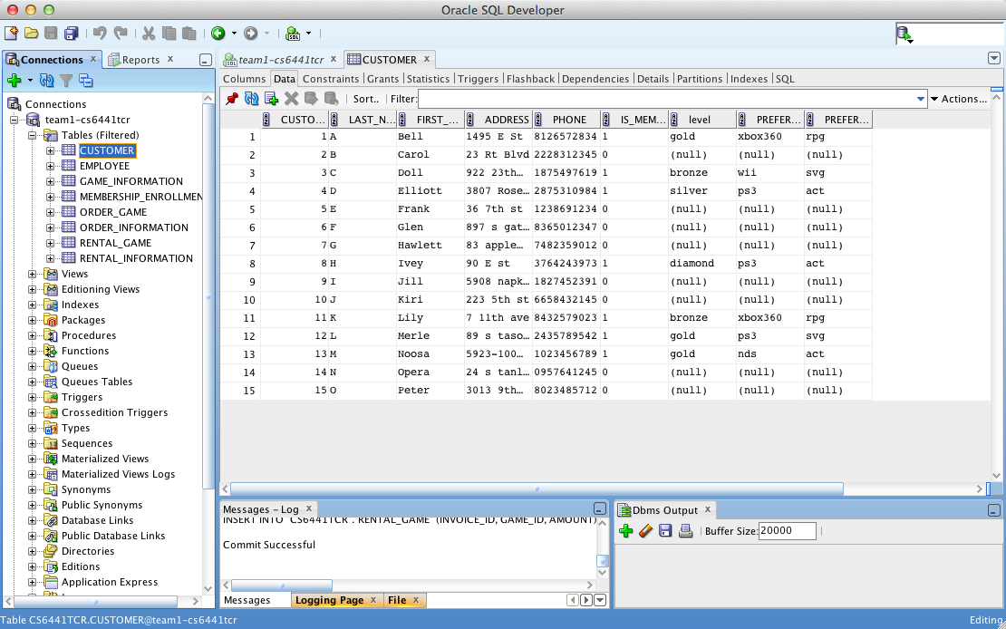

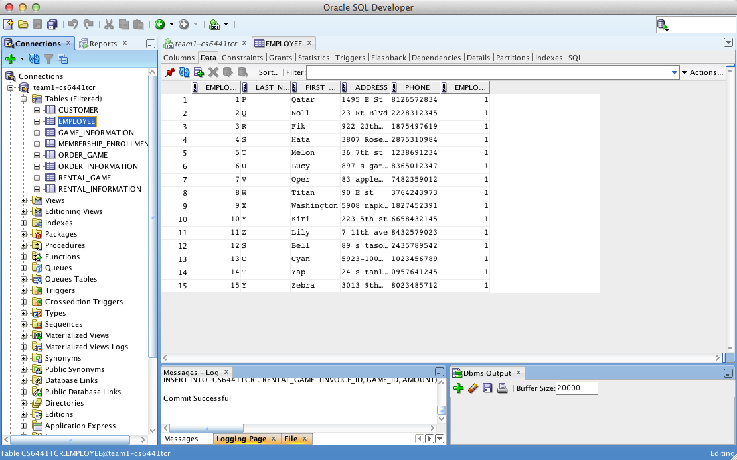

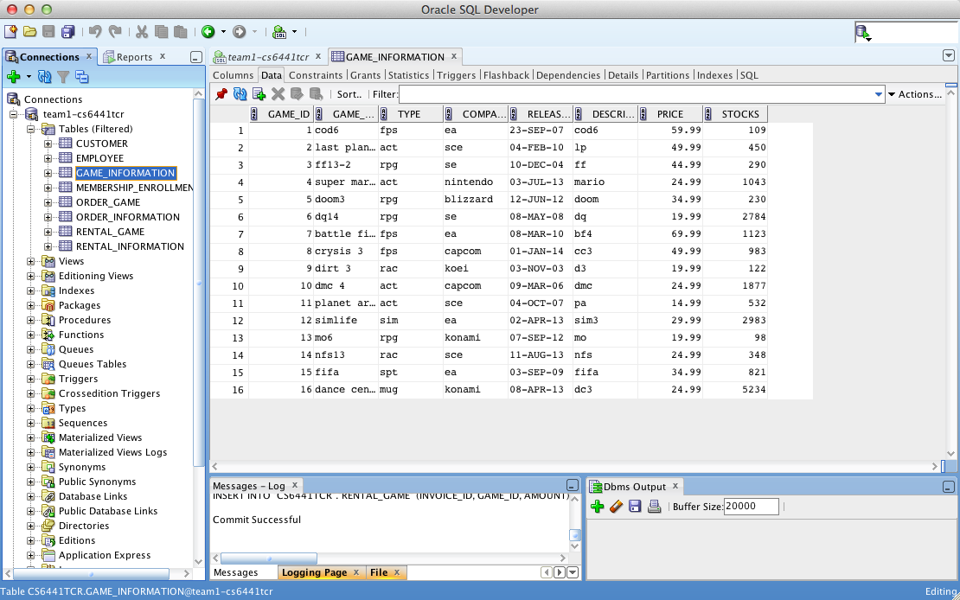

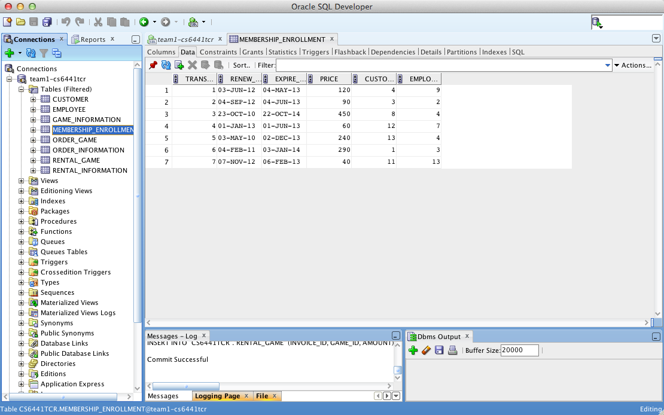

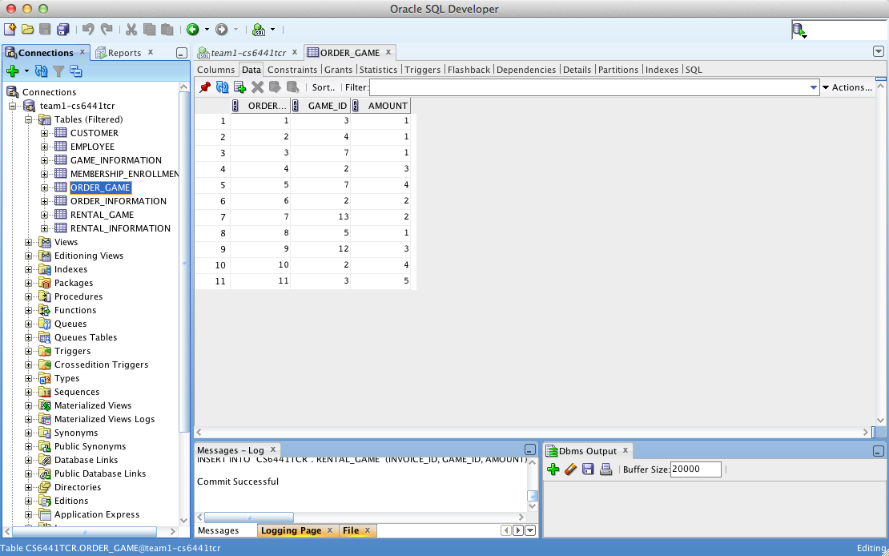

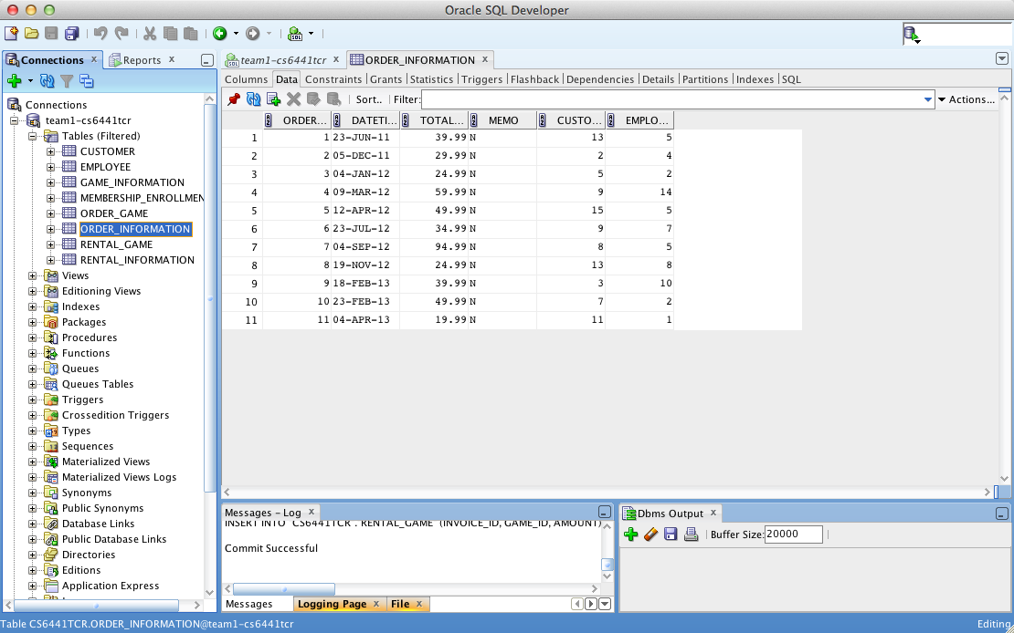

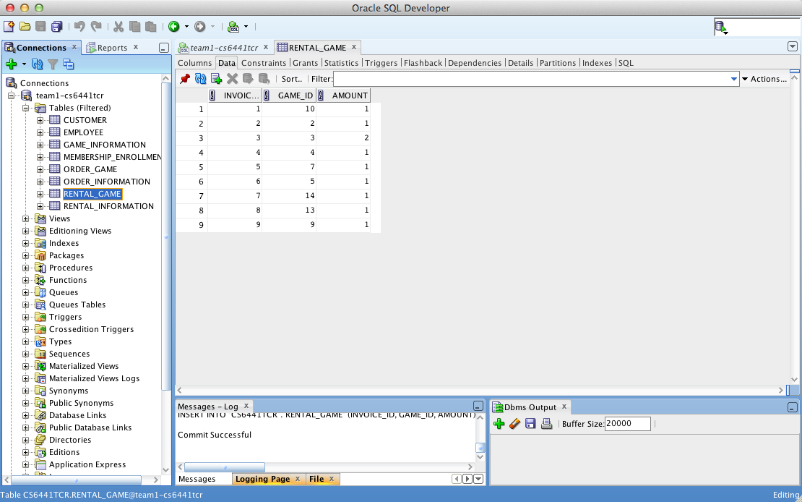

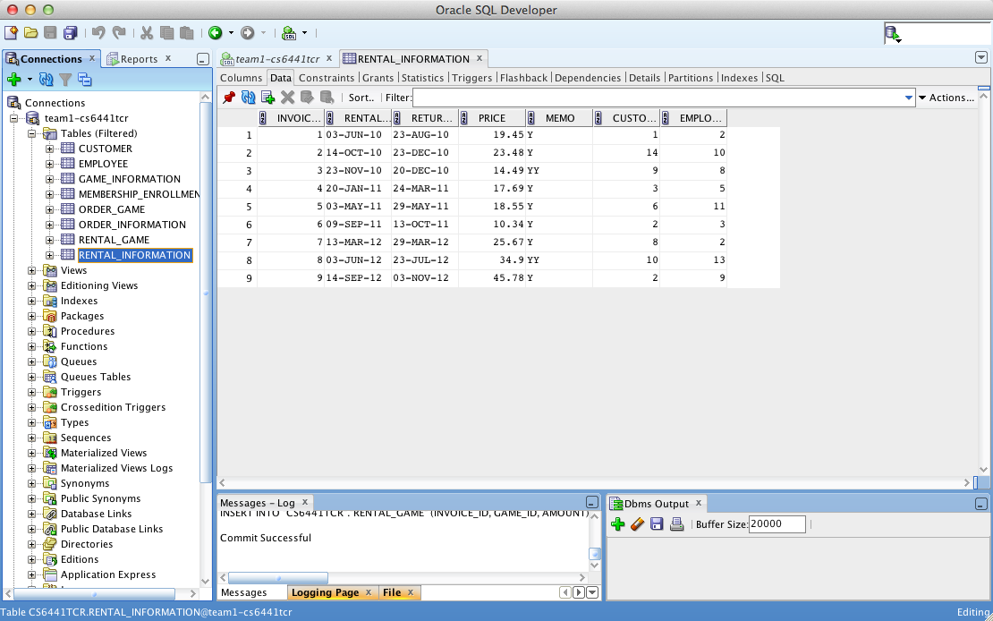

**Query Statement**

--------------------------------------------------

-----SELECT QUERY STATEMENT

--------------------------------------------------

----LIST ALL CUSTOMER

SELECT * FROM CUSTOMER;

----LIST EMPLOYEES THAT MANAGED BY MANAGER THAT ID = 4

SELECT *

FROM EMPLOYEE

WHERE employee_id1=4;

----LIST ALL GAMES THAT GAMETYPE IS RPG

SELECT GAME_TITLE

FROM game_information

WHERE type='rpg';

----SOME GAMES IS READY TO SALE

SELECT GAME_TITLE "SALES READY", STOCKS, PRICE "CURRENT PRICE", PRICE*0.8 "SALES PRICE"

FROM game_information

WHERE STOCKS>1000 AND TRUNC(SYSDATE-RELEASE_DATE)>180;

----SHOW MEMBERSHIP NO.11 FAVIOURITE GAME

SELECT GAME_TITLE

FROM game_information, customer

WHERE customer.customer_id= 11 AND type = customer.preferred_gametype;

----MEMBERSHIP ENROLLMENT INFORMATION

SELECT LAST_NAME, FIRST_NAME, EXPIRE_DATE

FROM customer

RIGHT JOIN membership_enrollment

ON customer.customer_id=MEMBERSHIP_ENROLLMENT.CUSTOMER_ID;

----SHOW MANAGERMENT RELATIONSHIP

SELECT EMP.LAST_NAME AS "EMPLOYEE LASTNAME",

EMP.FIRST_NAME AS "EMPLOYEE FIRSTNAME",

MAN.FIRST_NAME AS "MANAGER FIRSTNAME"

FROM EMPLOYEE EMP

LEFT JOIN EMPLOYEE MAN

ON EMP.EMPLOYEE_ID1=MAN.EMPLOYEE_ID;

----SHOW CUSTOMER LIKED GAME INFORMATION

SELECT LAST_NAME, FIRST_NAME, GAME_TITLE, RELEASE_DATE

FROM CUSTOMER

INNER JOIN GAME_INFORMATION

ON CUSTOMER.PREFERRED_GAMETYPE=GAME_INFORMATION.TYPE;

----SHOW MANAGERMENT RELATIONSHIP

SELECT LAST_NAME, FIRST_NAME,

(SELECT FIRST_NAME FROM EMPLOYEE MAN WHERE MAN.EMPLOYEE_ID = EMP.EMPLOYEE_ID1) "MANAGER NAME"

FROM EMPLOYEE EMP;

----SHOW CUSTOMER NO.13 ALL ORDERS

SELECT FIRST_NAME, ORDER_ID

FROM CUSTOMER, ORDER_INFORMATION

WHERE CUSTOMER.CUSTOMER_ID=ORDER_INFORMATION.CUSTOMER_ID AND CUSTOMER.CUSTOMER_ID=13;

----SHOW MEMBERS THAT WILL EXPIRE LESS THAN 30 DAYS

SELECT CUSTOMER_ID, FIRST_NAME

FROM CUSTOMER

WHERE CUSTOMER_ID

IN (SELECT CUSTOMER_ID FROM MEMBERSHIP_ENROLLMENT WHERE TRUNC(EXPIRE_DATE-SYSDATE) < 30);

----SHOW CUSTOMER ALL BUYS WITH DESCEND

SELECT CUSTOMER_ID, SUM(TOTAL_PRICE) AS "CUSTOMER TOTAL COMSUMPTION"

FROM ORDER_INFORMATION

GROUP BY customer_id

ORDER BY "CUSTOMER TOTAL COMSUMPTION" DESC;

----SHOW EMPLOYEE SELLS WITH DESCEND

SELECT EMPLOYEE_ID, SUM(TOTAL_PRICE) AS "EMPLOYEE TOTAL SELLS"

FROM ORDER_INFORMATION

GROUP BY EMPLOYEE_ID

ORDER BY "EMPLOYEE TOTAL SELLS" DESC;

----INFORMATION ABOUT ORDER THAT GREATER THAT $50

SELECT CUSTOMER_ID, SUM(TOTAL_PRICE) FROM ORDER_INFORMATION GROUP BY CUSTOMER_ID HAVING SUM(TOTAL_PRICE)>50;

----ALL SELLS IN 2012

SELECT SUM(TOTAL_PRICE) FROM ORDER_INFORMATION WHERE DATETIME BETWEEN '01-JAN-12' AND '31-DEC-12';

Attaching the ddl file:

**DML AND AUDIT**

ALTER TABLE EMPLOYEE

ADD

(

CREATE_DATE DATE,

CREATE_BY VARCHAR2(20),

UPDATE_DATE DATE,

UPDATE_BY VARCHAR2(20)

);

ALTER TABLE CUSTOMER

ADD

(

CREATE_DATE DATE,

CREATE_BY VARCHAR2(20),

UPDATE_DATE DATE,

UPDATE_BY VARCHAR2(20)

);

create or replace

TRIGGER ADDCUSTOMER

BEFORE INSERT ON CUSTOMER

FOR EACH ROW

DECLARE

V_USERNAME VARCHAR2(20);

BEGIN

SELECT USER INTO V_USERNAME

FROM DUAL;

:NEW.CREATE_DATE := SYSDATE;

:NEW.CREATE_BY := V_USERNAME;

END;

create or replace

TRIGGER UPDCUSTOMER

BEFORE UPDATE ON CUSTOMER

FOR EACH ROW

DECLARE

V_USERNAME VARCHAR2(20);

BEGIN

SELECT USER INTO V_USERNAME

FROM DUAL;

:NEW.UPDATE_DATE := SYSDATE;

:NEW.UPDATE_BY := V_USERNAME;

END;

create or replace

TRIGGER ADDEMPLOYEE

BEFORE INSERT ON EMPLOYEE

FOR EACH ROW

DECLARE

V_USERNAME VARCHAR2(20);

BEGIN

SELECT USER INTO V_USERNAME

FROM DUAL;

:NEW.CREATE_DATE := SYSDATE;

:NEW.CREATE_BY := V_USERNAME;

END;

create or replace

TRIGGER UPDEMPLOYEE

BEFORE UPDATE ON EMPLOYEE

FOR EACH ROW

DECLARE

V_USERNAME VARCHAR2(20);

BEGIN

SELECT USER INTO V_USERNAME

FROM DUAL;

:NEW.UPDATE_DATE := SYSDATE;

:NEW.UPDATE_BY := V_USERNAME;

END;

create or replace

TRIGGER ACTIVEMEM

AFTER INSERT ON MEMBERSHIP_ENROLLMENT

FOR EACH ROW

BEGIN

UPDATE CUSTOMER

SET IS_MEMBERSHIP = 1

WHERE CUSTOMER_ID = :new.CUSTOMER_ID;

END;

create or replace

TRIGGER SUBRENTSTOCK

AFTER INSERT ON RENTAL_GAME

FOR EACH ROW

BEGIN

UPDATE GAME_INFORMATION

SET STOCKS = STOCKS - :new.AMOUNT

WHERE GAME_ID = :new.GAME_ID;

END;

create or replace

TRIGGER SUBSOLDSTOCK

AFTER INSERT ON ORDER_GAME

FOR EACH ROW

BEGIN

UPDATE GAME_INFORMATION

SET STOCKS = STOCKS - :new.AMOUNT

WHERE GAME_ID = :new.GAME_ID;

END;

ATTACHING DDL FILE:

